.
- INTRODUCTION
In recent years, digital learning platforms have gained remarkable attention as education increasingly shifts toward interactive and personalized experiences. Traditional learning methods often lack engagement, leading to reduced attention span and poor knowledge retention among students. To address these challenges, the integration of technology, multimedia, and adaptive learning systems has become essential. Smart learning environments are designed to make education more dynamic, accessible, and effective by leveraging interactive tools, visual feedback, and intelligent content delivery.
This project, titled SmartLearn, introduces an interactive web-based learning platform that enhances the study experience by combining educational content with engaging background music and visual effects. The system aims to improve student focus, reduce monotony, and create an enjoyable learning atmosphere. SmartLearn is built using modern web technologies with an emphasis on simplicity, user engagement, and responsive design. The platform features an animated background, smooth user interface, and easy navigation to ensure a distraction-free and immersive study experience.
The proposed SmartLearn system not only promotes better concentration but also encourages consistent study habits through an aesthetically pleasing interface. By integrating learning with subtle musical and visual stimulation, the platform bridges the gap between education and emotional engagement. Thus, SmartLearn serves as an innovative step toward redefining online learning environments, making them more interactive, motivating, and adaptable to individual learning preferences.

- LITERATURE SURVEY

Paper Title | Author | Year | Methodology/  Concept | Gap Identification
Grid impact of electric vehicle fast charging stations[1] | L. Wang, Z. Qin,  T. Slangen, P. Bauer, &  T. van Wijk | 2024 | This project about the fast-charging station for Electric Vehicle. | Paper is more inclined grid impact of Electric Vehicle based system as present in Electric Vehicle fast charging stations.
Review of recent trends in optimization techniques for plug-in hybrid, and electric vehicle charging infrastructures  [2] | I. Rahman, P. M. Vasant, M. Singh, M. Abdullah-Al-Wadud, and N. Adnan | 2023 | Integrated challenges of plug-in hybrid electric vehicles (PHEV) and EV charging infrastructures are assessed through the various optimization techniques. | Paper is the more inclined towards Techniques for plug-in hybrid, and electric vehicle charging infrastructures-based system about Electric Vehicle charging system.
Overview of wireless charging technologies for electric vehicles  [3] | C. Qiu, K. T. Chau, T. W. Ching, & C. Liu | 2022 | The Author research paper introduced wireless or inductive charging solutions that enable in-motion charging of the EVs which makes EV more favorable for the daily use of many drivers. | Paper it was more inclined Overview of wireless charging technologies for Electric Vehicle based system Dynamic Wireless charging system Electric Vehicle.
A FACTS Device: Distributed Power-Flow Controller (DPFC)[4] | Z. Yuan,  S. W. H. d. Haan,  J. B. Ferreira &  D. Cvoric | 2021 | In this paper about the wireless charging is important for electric vehicles in order to overcome the charging duration. | Paper is the more inclined Distributed Power-Flow Controller for Electric Vehicle based system Dynamic Wireless charging system Electric Vehicle.
Research progress of the key technologies for Dynamic wireless Charging of electric vehicle  [5] | C. Zhu,  J. Jiang,  K. Song &  Q. Zhang | 2020 | This paper representing the wireless charging technology, there are more static wireless technologies, while dynamic charging mode is only a . | The dynamic wireless Charging of electric vehicle-based system for Electric Vehicle.

Paper Title | Author | Year | Methodology/  Concept | Gap Identification
Intelligent Tutoring Systems: A Review of Current Trends and Future Directions | K. VanLehn | 2019 | This paper cusses how AI-driven tutoring systems personalize learning by analyzing student performance and adapting teaching strategies accordingly | Focuses mainly on adaptive instruction; lacks creative and interactive formats like stories or flashcards that make learning engaging.
Adaptive Learning using Artificial Intelligence in Education | S. Dwivedi & R. Pattnaik | 2020 | presents adaptive AI algorithms that modify the learning path according to learner ability to improve understanding and retention | Does not include dynamic visuals, theme customization, or multi-format responses like SmartLearn provides.
AI-Powered Chatbots for Personalized Learning Assistance | P. Hwang & L. Chen | 2021 | Uses Natural Language Processing (NLP) to create chatbot systems that answer user queries and provide study assistance. | Limited to plain text-based conversation; lacks multimedia and interactive outputs such as flashcards and quizzes.
Gamification and Interactive Learning Environments using Web Technologies | A. Sharma & D. Kumar | 2022 | Explores how game-like interfaces, points, and rewards increase motivation and learner engagement in web platforms. | Lacks AI integration and personalized storytelling features; SmartLearn combines both for deeper engagement.
AI-Powered Personalized Learning Systems for Student Engagement | A. Sharma, R. Gupta, & M. Patel | 2021 | Used AI and NLP to create adaptive learning materials and personalized quizzes for students. | The system lacked multi-format learning like stories, flashcards, and mock tests — which SmartLearn provides through an all-in-one interactive AI-based platform.

- PROJECT OBJECTIVES
The primary objectives of this study can be summarized as follows
- Main objective of project is to design an AI-based interactive learning platform
- To enhance focus and memory retention using AI tools and engaging visuals.
- To implement AI-based tool selector for personalized study support.
- To improve user motivation and learning outcomes compared to traditional systems.

4. PROBLEM FORMULATION
4.1 Existing System
In the current educational scenario, most online learning platforms focus primarily on providing static study materials such as text, videos, and quizzes. While these resources are useful, they often fail to sustain student attention and motivation for long periods. Many learners struggle with distraction, boredom, and lack of engagement during self-study sessions. Existing systems rarely integrate intelligent or interactive elements that adapt to the learner’s focus level or learning style. Additionally, there is minimal use of artificial intelligence to personalize the learning experience or to stimulate memory retention. As a result, students face difficulties in maintaining consistency, improving memory, and achieving effective learning outcomes through conventional e-learning tools.
4.2 Proposed System
The proposed system, SmartLearn: An AI-Based Memory Booster, introduces an interactive and intelligent learning environment that enhances focus and retention through AI-driven features and engaging visuals. SmartLearn integrates various tools such as an AI-based tool selector and dynamic background animations to make the learning process more immersive and enjoyable. The system utilizes HTML, CSS, JavaScript, Tailwind CSS, and Java (Spring Boot) for developing a responsive, web-based platform that operates efficiently across devices.
Artificial Intelligence (AI) is employed to recommend suitable tools or study aids based on user behavior and learning patterns. The interface provides an animated, interactive background that keeps the environment visually stimulating without causing distraction. This approach not only improves memory retention but also enhances motivation and productivity. SmartLearn is designed to overcome the limitations of traditional online study systems by combining intelligence, interactivity, and aesthetic appeal into a single platform that supports long-term engagement and better learning outcomes.

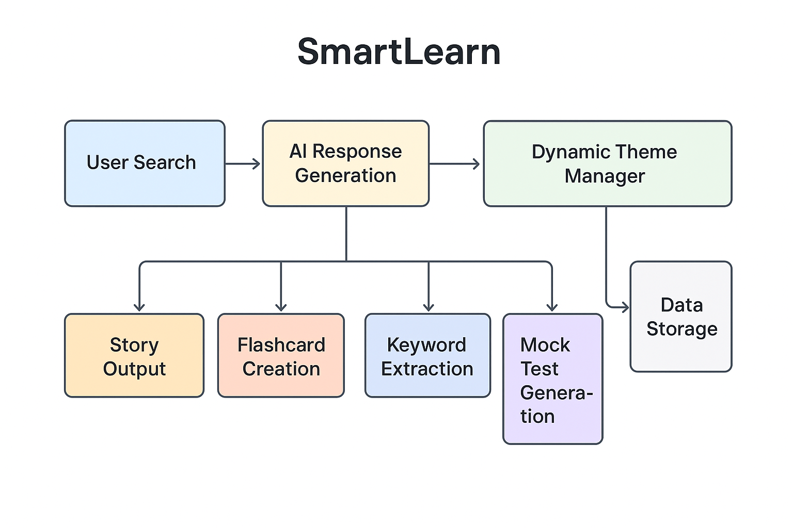
Fig-1 Block diagram

The architecture of SmartLearn is designed to provide a seamless flow from user input to interactive learning outputs. The process begins when the user enters a topic or query in the search section. This input is processed by the Smart Response Generator, which analyzes the query and generates educational content in multiple engaging formats such as story explanation, flashcards, keywords extraction, and mock test questions. Each of these modules plays a distinct role — the Story Module explains concepts creatively, the Flashcard Module simplifies revision, the Keyword Module highlights key terms for memory aid, and the Mock Test Module checks understanding through quick quizzes. The generated content is then displayed in a well-structured UI interface, allowing users to navigate between formats easily. Finally, all user interactions are saved locally, ensuring continuity and personalization in future learning sessions. This interconnected flow ensures that SmartLearn delivers a dynamic, adaptive, and engaging learning experience
The figure below represents the overall User Interface of the SmartLearn system.

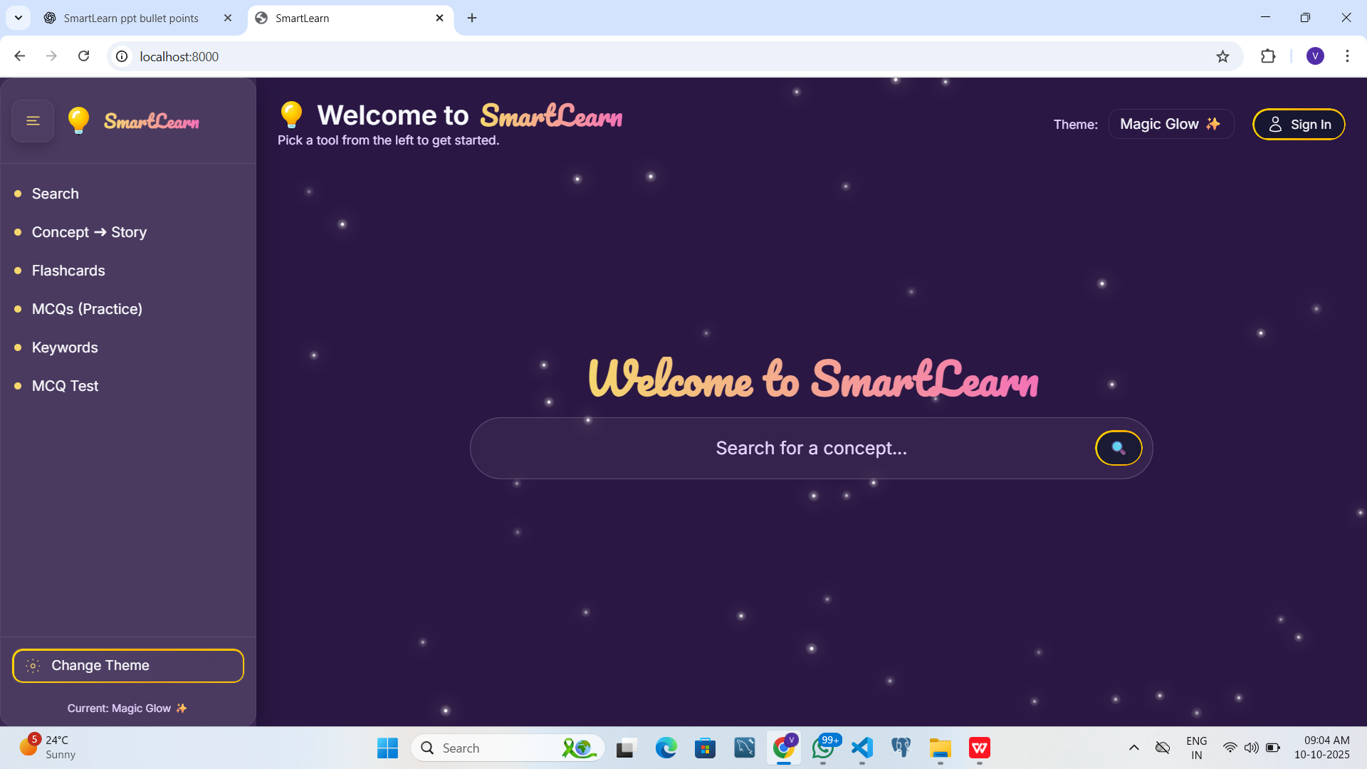
Fig - 2 UI of the SmartLearn
When a user logs into the system, the interface collects basic preferences and study patterns. This data is processed by the AI module, which suggests appropriate study tools or techniques that best suit the user’s focus level. The Interactive Dashboard displays progress, provides access to learning resources, and controls background animations or music to create an ideal study atmosphere. The Backend (Spring Boot) handles data processing, user authentication, and tool integration, while the Database securely stores user details, progress history, and AI-generated insights. Together, these modules create a seamless and intelligent learning experience that motivates users to study more effectively and consistently.

5. RESEARCH METHODOLOGY
The proposed work is planned to be carried out in the following manner:
- Study of Existing Learning Platforms.
- Problem Identification through Literature Review.
- Design and Development of System Architecture.
- Implementation of AI-Based Tool Selector.
- Integration of Interactive and Visual Featuresies.
- Testing and Performance Evaluation.
- Comparative Analysis with Existing Platforms.

.

6. FACILITIES REQUIRED:
I)) Hardware- 1) Computer System or Laptop
2) High-Speed Internet Connection

II)) Software- 1) Frontend Technologies: HTML, CSS, JavaScript, Tailwind CSS
2) Backend Framework: Java (Spring Boot)
3) Database: PostgreSQL
4) Development Tools: Visual Studio Code
5) AI Libraries and APIs: OpenAI API
6) Version Control: Git and GitHub for source code management
7) Web Browser: Google Chrome

- PLAN OF RESEARCH:

SR. NO. | STEPS | Month
1. | Detail study of some more papers | June 2025
2. | Problem Formulation | July 2025
3. | Study of tools | August 2025
4. | Hardware model design | November-Decmber
5. | Paper Publication | August2025 and Septmebr 2025
6. | Thesis writing | January

REFERENCES

[1] Alalwan, N., Al-Rahmi, W., Alfarraj, O., & Alzahrani, A. (2020). E-learning system adoption: A study on the impact of system quality, service quality, and content quality. Education and Information Technologies, Springer.

[2] Li, X., & Wang, J. (2021). Intelligent learning systems based on artificial intelligence for personalized education. International Journal of Emerging Technologies in Learning (iJET).

[3]Hussain, M., Zhu, W., Zhang, W., & Abidi, S. (2018). Student engagement and learning through AI-powered educational platforms. Computers & Education, Elsevier.

[4] Wulanjani, A., & Rachmadyanti, P. (2019). Interactive learning media design using HTML, CSS, and JavaScript for education. Journal of Educational Technology, 4(2), 85–92.

[5] Kaur, H., & Kaur, R. (2022). Role of adaptive learning in enhancing student understanding using intelligent systems. International Journal of Computer Applications, 184(5).

[6] OpenAI (2024). Generative AI for personalized education: Enhancing learning experiences through interactive content. OpenAI Research Blog.

[7] Johnson, L., & Lee, M. (2023). User interface design approaches for interactive educational web platforms. Journal of Web Engineering and Education, 6(2), 102–110.

- Banerjee, R., & Mehta, P. (2021). Enhancing learning outcomes through AI-based question generation and assessment tools. International Journal of Computer Science Education, 19(4), 95–103.

[9] Rao, S., & Thomas, A. (2022). Gamification and flashcard-based learning in modern e-education. Education and Information Technologies, Springer.

[10] Singh, P., & Kumar, D. (2023). Integration of AI and web technologies for adaptive education systems. IEEE Access, 11, 15730–15738.

[11]Patel, M., & Gupta, S. (2020). AI-driven educational platforms for interactive learning environments. International Journal of Scientific & Technology Research, 9(5), 560–567

[12] Sharma, A., & Verma, R. (2021). Web-based learning tools for enhancing cognitive engagement in students. International Journal of Advanced Research in Computer Science, 12(3), 45–50.
.

WEBSITES VISITED

- https://openai.com/research/index/
- https://www.w3schools.com/js/default.asp
- https://developer.mozilla.org/en-US/docs/Web/API/Fetch_API
- https://www.geeksforgeeks.org/javascript/javascript-tutorial/
- https://research.ibm.com/artificial-intelligence

Dr. Shrikant Zade Mr. Nischint Makode
Project Guide Project Coordinator

Dr. Shrikant Zade
HoD,CSE

